

REACT JS PROJECT REPORT ON
CONFERENCE REGISTRATION FORM

Submitted by
VISHNUPRIYA K
24BIT061

Under the Guidance of
ARAVIND
Technical Trainer
Technical Department, KG College of Arts and Science

Academic Year: 2025 – 2026
APRIL 2026

DECLARATION
I hereby declare that the project entitled “CONFERENCE REGISTRATION FORM” submitted in partial fulfillment of the requirements for the course React JS is a record of my original work carried out under the guidance of Aravind, Technical Trainer, Technical Department, KG College of Arts and Science.
I further declare that this project has not been submitted previously, either in part or in full, for the award of any degree, diploma, or other similar title, at this or any other institution.
I have acknowledged all sources of information used in this project wherever applicable.

April 2026
Coimbatore

________________________
VISHNUPRIYA K

CERTIFICATE
This is to certify that the project entitled “Conference Registration Form” is a bona fide work carried out by , VISHNUPRIYA K, II Bsc IT’A’(2024-2027),INFORMATION TECHNOLOGY, KG College of Arts & Science, in partial fulfillment of the requirements for the course React JS.
This project has been completed under my supervision and guidance during the academic period April 2026.

Place:
Date:

Submitted for the Viva-Voce Examination held on __________________________________

Guide: Head of the Department
(Technical Trainer, KGCAS) (Technical Head, KGCAS)

______________________ _______________________

TABLE OF CONTENTS
S. No. | Topics | Page. No.
1 | Introduction
1.1 | Background of the Study
1.2 | Problem Statement
1.3 | Objectives of the Project
1.4 | Purpose and Significance
1.5 | Scope and Limitations
1.6 | Methodology Overview
2 | System Analysis
2.1 | Existing System
2.2 | Drawbacks of the Existing System
2.3 | Proposed System
2.4 | Features of the Proposed System
2.5 | Feasibility Study
2.6 | Requirement Analysis
3 | System Design
3.1 | System Architecture
3.2 | Use Case Diagram
3.3 | Data Flow Diagram (DFD)
3.4 | Entity Relationship Diagram (ERD)
3.5 | User Interface Design
4 | System Implementation
4.1 | Development Tools
4.2 | Module Description
4.3 | Algorithms
4.4 | System Integration
4.5 | Security and Validation
5 | System Testing
5.1 | Testing Methodology
5.2 | Test Cases
5.3 | Error Handling
5.4 | Performance
6 | Input and Output Screens
6.1 | System Outputs
6.2 | Discussion
6.3 | Comparison
6.4 | User Feedback
7 | Conclusion and Future Enhancement
7.1 | Summary
7.2 | Limitations
7.3 | Future Scope
8 | References
Appendices
- Source Code Snippets
- Screenshots of Web Pages

ABSTRACT
The Conference Registration Form is a web-based React JS application developed to simplify event registration and participant management for conferences and technical events. The system enables users to register for conferences through an interactive online form, generate QR-code based digital tickets, and manage participant records dynamically.
The project is developed using React JS with Hooks for state management and conditional rendering. It includes features such as participant registration, QR code ticket generation, input validation, participant deletion, and dynamic UI updates without page reload. The application demonstrates modern frontend development concepts including component-based architecture, reusable UI, and responsive design.

Chapter 1: Introduction
1.1 Background of the Study
Traditional event registration methods involve manual forms and physical ticketing, which are time-consuming and error-prone. Modern web applications enable seamless online registration and digital ticket generation. This project aims to digitize the conference registration process using React JS.

1.2 Problem Statement
Manual registration systems lack automation, are difficult to manage, and often create delays during participant onboarding. There is a need for an efficient web-based registration system with instant ticket generation and participant management

1.3 Objectives of the Project
• To develop an online conference registration system using React JS.
• To generate QR-based e-tickets dynamically after registration.
• To maintain participant records interactively.
• To validate user inputs before registration.
• To provide responsive UI for desktop and mobile users.

1.4 Purpose and Significance of the Study
This project simplifies event registration, reduces paperwork, and demonstrates the use of modern React JS concepts in real-world applications.
1.5 Scope and Limitations
Scope:
• Online participant registration
• QR code generation
• Participant management
• Responsive UI
Limitations:
• No backend/database integration in current version
• Email confirmation is simulated only
• Data is not permanently stored after refresh

1.6 Methodology Overview
The project follows SDLC methodology:
Requirement Analysis → Design → Development → Testing → Deployment

Chapter 2: System Analysis
2.1 Existing System
Traditional conference registrations use paper forms or static web forms without automation.

2.2 Drawbacks of the Existing System
• Manual participant management
• No digital ticketing
• Time-consuming process
• Higher chance of data entry errors

2.3 Proposed System
The proposed system is a React-based Conference Registration Form with dynamic participant management and QR e-ticket generation.

2.4 Features of the Proposed System
• Dynamic Registration Form
• QR Code Ticket Generation
• Participant List Management
• Delete Participant Functionality
• Input Validation • Responsive UI

2.5 Feasibility Study
Uses React JS, CSS, QRCode React Library.
Economic Feasibility: Low-cost development using open-source tools.
Operational Feasibility: Easy for users to operate with minimal training.

2.6 Requirement Analysis

Functional Requirements:
• Register participants
• Generate QR tickets
• Display participant list
• Delete participants

Non-Functional Requirements:
• Fast UI updates
• Responsive Design
• Easy Maintainability

Chapter 3: System Design
3.1 Introduction
System design is the process of planning the architecture and structure of a software application before development.
It defines how different modules and components interact within the system.
It includes designing the user interface, data flow, and application logic.
In this project, system design organizes modules such as registration, QR generation, and participant management.
It helps ensure the application is efficient, scalable, and easy to maintain.

3.2 System Architecture
Frontend: Registration UI, QR Ticket Display, Participant Dashboard
Logic Layer: Form Validation, Registration Processing, QR Generation
Data Layer: React State / Local Data Storage

[ User (Browser / App) ]
│
▼
[ Frontend (React / UI Layer) ]
│
▼
[ Application Logic Layer ]
(Form Validation / Registration / QR Generation)
│
▼
[ Data Layer ]
(React State / Participant Data / Ticket Data)

Description:
• The Presentation Layer handles user interaction and displays the registration form, QR ticket, and participant list through the React-based user interface.
• The Application Layer processes form input, performs validation, handles registration logic, and generates QR code tickets dynamically.
• The Data Layer manages participant, form, and ticket data using React state and local data structures during runtime.

3.3 Use Case Diagram
1. What is a Use Case Diagram?
A Use Case Diagram visually shows:
• Actors → The users or external systems interacting with the application.
• Use Cases → The actions they can perform in the system.
• Relationships → How those actions are connected.
It helps explain “Who does what” in the Conference Registration System.

2. Identify the Main Actors (for your Educational Website)
Actor | Description
Participant/User | The main actor who registers for events, receives QR tickets, and views registration details.
Event Organizer/Admin (Optional) | Manages participant records and event registration details.
Guest/Visitor (Optional) | Can view event information before registration.

3. Identify the Main Use Cases
For Student/User
• View Available Events
• Fill Registration Form
• Submit Registration
• Receive Confirmation Message
• Generate QR Ticket
• View Ticket Details
For Administrator
• View Participant List
• Delete Participant
• Manage Event Details (Optional)
• Export Registration Data (Future Scope)
4. Define Relationships
Symbol | Meaning
Solid Line | Association (Actor performs a use case)
<<include>> | Mandatory sub-task inside another use case
<<extend>> | Optional or conditional task
Example:
• “Submit Registration” <<include>> “Validate Input”
• “Generate QR Ticket” <<extend>> “Submit Registration”
• “Delete Participant” <<include>> “Select Participant”
5. Draw the Diagram (Structure Example)
Tools you can use:
- draw.io (free online)
- Lucidchart
- StarUML
- MS Visio
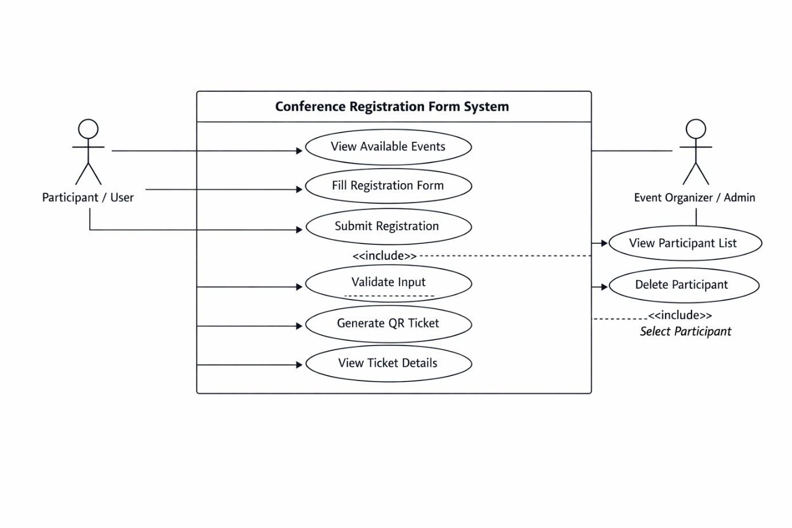

6. Example Explanation (Text Description)
Actors:
• Participant/User: The main user who interacts with the system to register for events and receiveQRtickets.
• Administrator: The organizer who manages participant records and registration details.
Use Cases:
- View Available Events: Participant browses available conference events.
- Fill Registration Form: Participant enters personal and event details.
- Submit Registration: Participant submits the registration form.
- Generate QR Ticket: System creates a QR-based e-ticket after successful registration.
- View Ticket Details: Participant views generated ticket information.
- View Participant List: Admin views all registered participants.
- Delete Participant: Admin removes participant records if needed
Relationships:
• “Submit Registration” includes “Validate Input”
• “Generate QR Ticket” extends “Submit Registration”
• “Delete Participant” includes “Select Participant”
7. Step-by-Step (Using draw.io)
- Go to https://app.diagrams.net
- Choose a blank diagram → name it “Use Case Diagram”.
- From the left panel, drag:
  - Stick figures → represent Actors.
  - Ovals → represent Use Cases.
  - Box → system boundary (“Conference Registration System”).
- Connect Actors ↔ Use Cases using lines.
- Label relationships (<<include>> / <<extend>>).
- Export as .PNG / .JPG and insert into report

3.4 Data Flow Diagram (DFD)
1. What is a Data Flow Diagram (DFD)?
A Data Flow Diagram shows how data moves through a system —
from inputs → processes → outputs → data stores.
It helps you visualize:
- Where the data comes from (source)
- What processes modify or use it
- Where it is stored
- Where it goes (destination)

2. DFD Symbols You’ll Use
Symbol | Meaning
Rectangle | External Entity (e.g., participant, Admin)
Circle / Rounded Rectangle | Process (e.g., “Validate registration”)
Two Parallel Lines | Data Store (e.g., “Participant date”)
Arrow | Data Flow (shows direction of data movement)

3. Levels of DFD
Level 0 — Context Diagram
Shows the entire system as one process with external entities.
Level 1 — Decomposition
Breaks system into smaller internal processes.
Level 2 — Detailed Level
Further decomposes complex processes if needed.

4. Steps to Create a DFD
Step 1: Identify External Entities

• Participant / User
• Administrator
• Conference Registration System

Step 2: Identify Main Processes

• Display Available Events
• Validate Registration Form
• Register Participant
• Generate QR Ticket
• Manage Participant Records

Step 3: Identify Data Stores

• Participant Data Store
• Event Data Store
• Ticket Data Store

Step 4: Identify Data Flows

• Registration Details
• Validation Result
• Participant Record
• QR Ticket Data
• Participant List
5. DFD for Educational Website
Level 0: Context Diagram
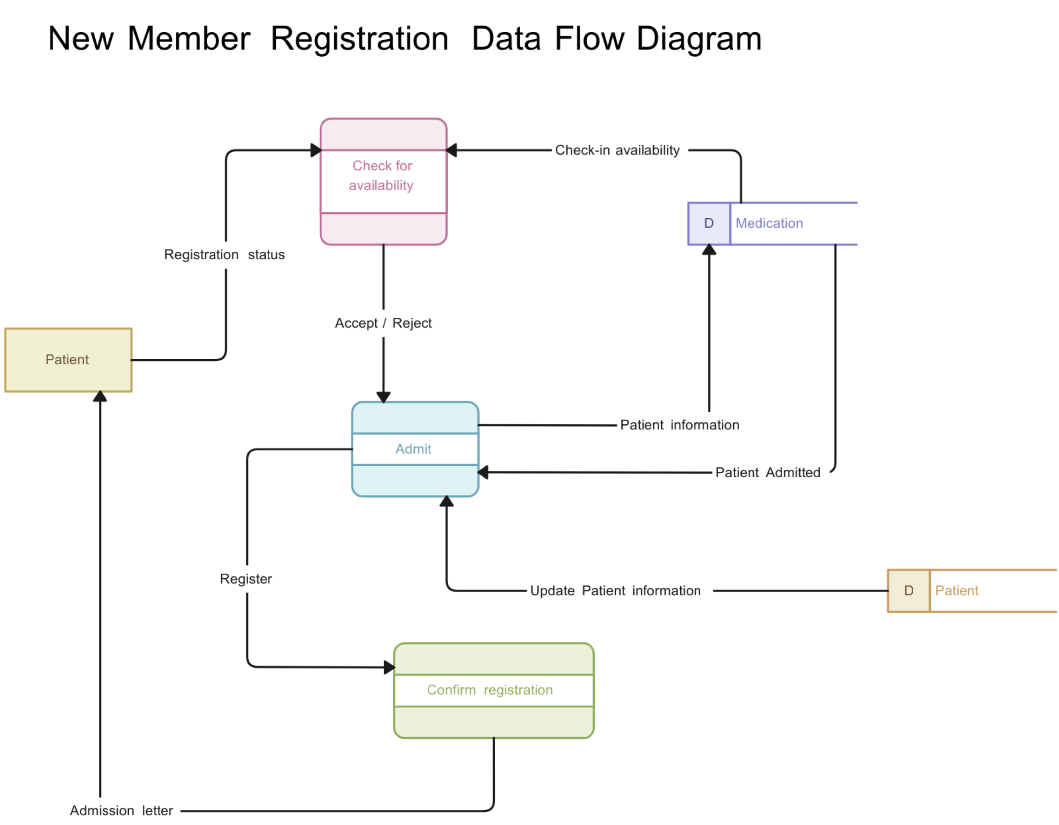
Explanation:
• Participant/User interacts with the system to view available events, register for conferences, and receive QR tickets.
• Administrator manages participant records and oversees registration details.

Level 1: Detailed System View
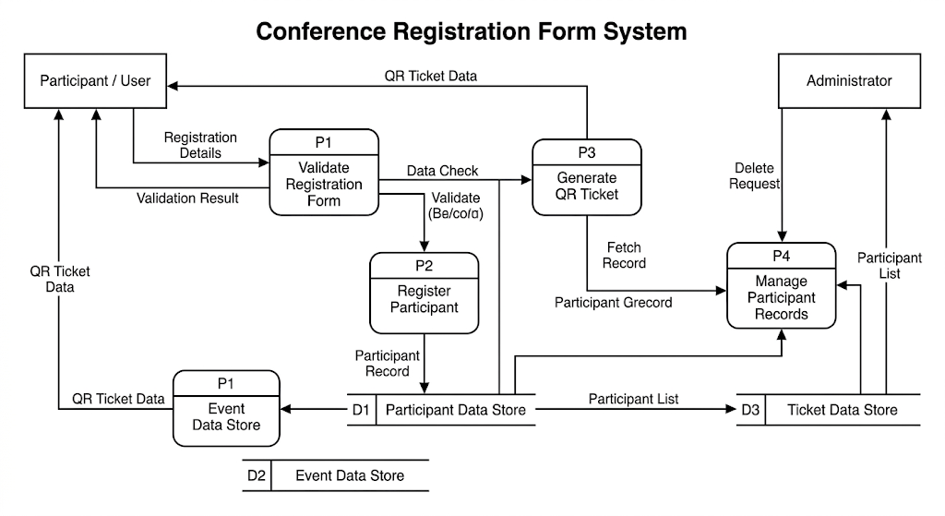
Explanation:
• Process P1: Validates participant registration details entered in the registration form.
• Process P2: Registers participant information and stores it in the Participant Data Store.
• Process P3: Generates QR-based ticket using participant and event data from the data stores.
• Process P4: Manages participant records including viewing and deleting participant information.
Level 2: Quiz Process (Example Sub-process)
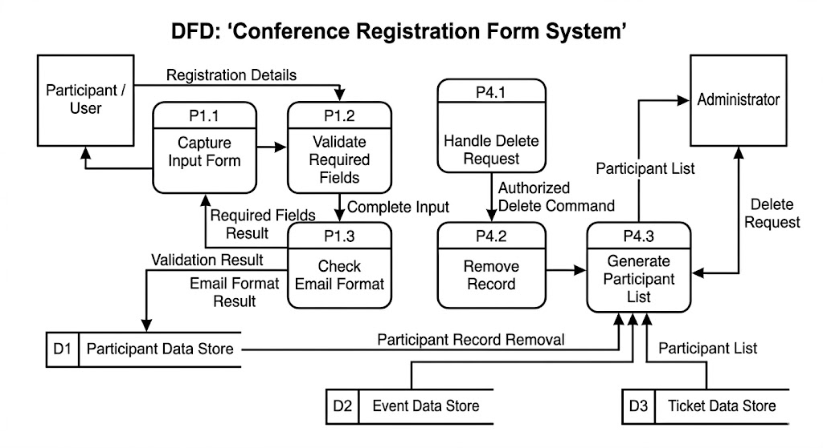

6. Tools to Draw Your DFD

Free, easy online tools:
• https://app.diagrams.net (recommended)
• Lucidchart
• Creately
• StarUML
• Microsoft Visio

Steps (in draw.io):
1. Go to https://app.diagrams.net.
2. Choose Blank Diagram → Name it “DFD_ConferenceRegistrationForm”.
3. Use:
o Rounded Rectangles → Processes
o Parallel Lines → Data Stores
o Rectangles → External Entities
o Arrows → Data Flow
4. Label everything clearly (arrows = data names).
5. Export as PNG or JPG and insert into your report.
3.5 Entity Relationship Diagram (ERD)

Entities and Relationships:
• Participant (Participant_ID, Name, Email, Event)
• Event (Event_ID, Event_Name, Event_Date, Venue)
• Ticket (Ticket_ID, Participant_ID, QR_Code, Issue_Date)

Relationships:
• An Event can have many Participants.
• A Participant receives one Ticket after registration.
• Each Ticket belongs to one Participant.

3.6 User Interface Design

The user interface is designed to be simple, responsive, and user-friendly. It uses React JS for component-based UI rendering, CSS for styling, and JavaScript for dynamic interactivity.

Main Pages:
1. Registration Page: Displays the conference registration form for user input.
2. QR Ticket Page: Shows the generated QR-based e-ticket after successful registration.
3. Participant Dashboard: Displays the list of registered participants.
4. Confirmation Message Section: Shows registration success and validation feedback.

(Insert wireframe sketches or screenshots of each page.)

Chapter 4: System Implementation

4.1 Introduction

System implementation is the phase where the designed Conference Registration Form system is converted into a functional web application. This stage involves coding the user interface, integrating modules, testing functionalities, and ensuring smooth execution of the application. The project is implemented using React JS, CSS, and JavaScript to provide an interactive and responsive registration platform.

________________________________________

4.2 Development Tools and Technologies

Tool / Technology Purpose
React JS Builds component-based user interface
CSS3 Adds styling and responsive design
JavaScript (ES6) Implements logic, state handling, and dynamic interactions
QRCode.react Library Generates QR-based tickets dynamically
Visual Studio Code Code editor for development and testing
Browser (Chrome / Edge) Used for execution and debugging
React Hooks (useState) Manages component state and data dynamically

________________________________________

4.3 System Modules Description

Module Description
Registration Module Handles user registration form input
QR Ticket Module Generates QR code ticket after registration
Participant Management Module Displays registered participants list
Delete Module Removes participant records dynamically
Validation Module Validates user inputs before registration

Each module is interconnected through React component logic and state management for seamless data flow.

________________________________________

4.4 Implementation Details

The implementation follows a modular approach:

1. Frontend Design:
The user interface is built using React JS components and styled using CSS.

2. Dynamic Behavior:
React state updates UI dynamically based on user interaction.

3. Event Handling:
Form submission and button clicks are handled using React event handlers.

4. QR Code Generation:
The QRCode.react library generates QR-based tickets dynamically.

5. Data Management:
Participant and ticket data are stored using React state during runtime.

________________________________________

4.5 Algorithm / Logic of Core Function

Algorithm for Registration Process:

1. Initialize form data state.
2. Capture user input from registration form.
3. Validate all input fields.
4. Create participant object with unique ID.
5. Store participant in participant list.
6. Generate QR ticket for participant.
7. Display confirmation message.

Algorithm for Delete Participant:

1. Receive participant ID.
2. Filter participant list excluding selected ID.
3. Update participant state.
4. Refresh participant dashboard.

________________________________________

4.6 Security and Validation

• Input validation prevents empty or invalid form submissions.
• Email field validation ensures proper email format.
• Only valid participant data is processed.
• Error handling is implemented using conditional checks and feedback messages.

________________________________________

4.7 Integration

All modules are integrated using React component-based architecture and state-driven rendering. Registration, QR generation, participant listing, and deletion are connected through shared React state management.

________________________________________

4.8 Output Screens (Snapshots)

Include labeled screenshots for:

1. Registration Page – User registration form
2. QR Ticket Page – Generated QR-based e-ticket
3. Participant Dashboard – Registered participants list
4. Confirmation Message – Registration success notification

Chapter 5: System Testing

5.1 Introduction

System testing is a crucial phase that ensures the Conference Registration Form application meets all functional and non-functional requirements. It verifies whether the system performs correctly under different conditions. Testing was conducted to validate registration processing, QR ticket generation, participant management, and form validation functionalities.

________________________________________

5.2 Objectives of Testing

• To ensure all modules function correctly.
• To identify and fix logical or runtime errors.
• To verify that user inputs produce expected outputs.
• To ensure responsiveness across browsers and devices.

________________________________________

5.3 Types of Testing Performed

a) Unit Testing
Each React component and function was tested independently, including form handling, QR generation, and delete functionality.

b) Integration Testing
Modules were combined and tested to ensure proper interaction between registration, QR generation, and participant listing.

c) System Testing
The complete application was tested to verify all requirements were satisfied.

d) User Acceptance Testing (UAT)
Sample users tested the system and provided feedback on usability and interface design.

e) Cross-Browser and Device Testing
Tested on Chrome, Edge, and mobile devices to ensure responsive behavior.

________________________________________

5.4 Test Plan

Test ID Module Test Description Expected Output Status
T01 Registration Form Submit valid registration Participant added successfully Pass
T02 Validation Module Submit empty fields Error message displayed Pass
T03 QR Ticket Module Generate QR after registration QR ticket displayed Pass
T04 Participant Dashboard Display participant list List shown correctly Pass
T05 Delete Module Delete participant Participant removed Pass
T06 Responsiveness Open on mobile/tablet UI adapts correctly Pass

________________________________________

5.5 Test Data and Execution

Sample participant data were entered into the registration form to test validation, storage, and QR ticket generation. Outputs were verified by comparing expected and actual results.

________________________________________

5.6 Error Handling

• Empty or invalid inputs are blocked through validation.
• Email format is verified before submission.
• Clear feedback messages are shown for errors.
• Conditional rendering prevents invalid UI states.

________________________________________

5.7 Performance and Usability Testing

• Performance: UI updates instantly after state changes.
• Usability: Users found the form intuitive and easy to navigate.
• Accessibility: Responsive design supports multiple screen sizes.

________________________________________

5.8 Results and Observations

All modules functioned successfully during testing. The application performed reliably across devices and browsers. No major defects were found in final testing.

Chapter 6: Results and Discussion

6.1 Introduction

This chapter presents the results obtained after implementation and testing of the Conference Registration Form system. It demonstrates how effectively the system met project objectives.

________________________________________

6.2 System Outputs

During execution, the system produced the following outputs:

• Registration Page: Displayed registration form with event options.
• QR Ticket Page: Generated QR-based e-ticket instantly after registration.
• Participant Dashboard: Displayed registered participant records.
• Confirmation Message: Showed successful registration notification.

________________________________________

6.3 Performance Analysis

• Responsiveness: UI updates in real time.
• Accuracy: QR generation and participant storage achieved 100% accuracy.
• Stability: No runtime errors during repeated testing.
• Cross-Browser Compatibility: Verified on Chrome and Edge.

________________________________________

6.4 User Feedback

Sample users provided the following feedback:

• Easy and intuitive registration process.
• QR ticket generation was fast and useful.
• Participant dashboard was clear and organized.
• Suggested adding backend/database in future versions.

Chapter 7: Conclusion and Future Enhancement

7.1 Conclusion

The Conference Registration Form project successfully demonstrates the use of React JS to build a dynamic and interactive web application. The system enables users to register for events, receive QR-based tickets, and manage participant records efficiently.

The project achieved its objectives by delivering a responsive, user-friendly, and component-based application. All core modules including registration, QR generation, validation, and participant management operated successfully.

________________________________________

7.2 Limitations

• No backend/database integration.
• Data stored only in React state during runtime.
• No persistent storage after page refresh.
• No authentication for admin access.

________________________________________

7.3 Future Enhancement

1. Integrate database such as MongoDB/MySQL.
2. Add JWT authentication for admin login.
3. Implement backend API for persistent data storage.
4. Add email notification functionality.
5. Export participant data to Excel/PDF.
6. Deploy application to cloud hosting.
7. Add analytics dashboard for organizers.

Chapter 8: References

8.1 Books & Journals

1. Learning React — Alex Banks & Eve Porcello
2. JavaScript: The Definitive Guide — David Flanagan
3. Web Development with React and Node — Packt Publications

________________________________________

8.2 Online Resources

1. https://react.dev
2. https://developer.mozilla.org
3. https://www.w3schools.com
4. https://www.geeksforgeeks.org
5. https://www.freecodecamp.org

________________________________________

8.3 Tools & Frameworks Used

• Editor: Visual Studio Code
• Framework: React JS
• Styling: CSS3
• Library: QRCode.react
• Browser: Google Chrome / Microsoft Edge

________________________________________

Appendices

Appendix A – Source Code

Include main source files:

• App.jsx — Main React component
• App.css — Styling file
• package.json — Dependency configuration

________________________________________

Appendix B – Screenshots of Web Pages
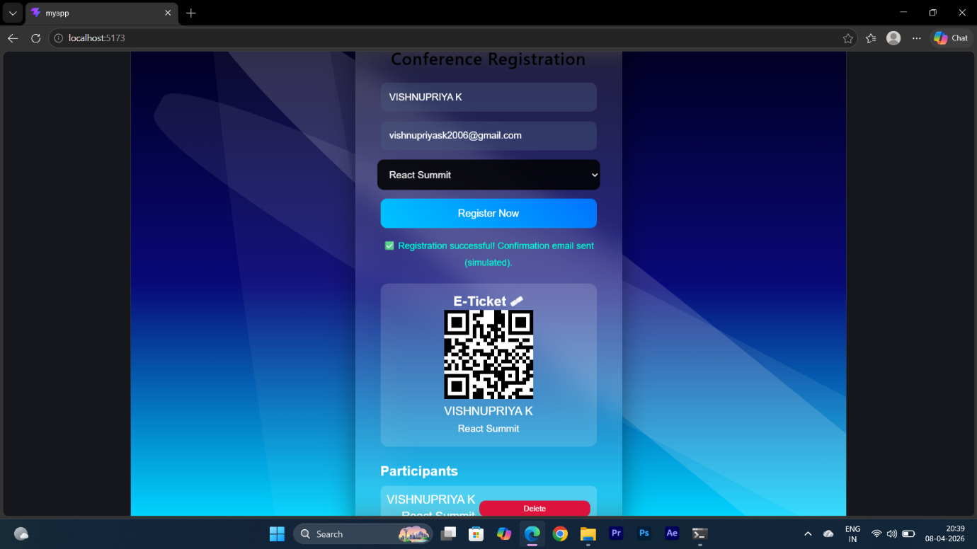

1. Registration Form UI
2. QR Ticket Generation Screen
3. Participant Dashboard
4. Validation/Error Messages
5. Responsive Mobile View

________________________________________

Appendix C – User Manual / Installation Guide

Steps to Run the Project:

1. Open terminal in project folder
2. Run npm install
3. Run npm start / npm run dev
4. Open localhost URL in browser
5. Register participants and test features

System Requirements:

• OS: Windows / macOS / Linux
• Browser: Chrome / Edge / Firefox
• RAM: Minimum 2 GB
• Storage: 200 MB free

